Анализ наклонного распространения акустического пучка
на основе уравнения Вестервельта
Иванов И.И.¹, Петров А.А. ²
¹студент, ²аспирант
Московский государственный университет имени М.В.Ломоносова,
физический факультет, Москва, Россия
E–mail: fio@email.ru
Lorem ipsum dolor sit amet, consectetur adipiscing elit. Donec non eros enim. Suspendisse sed metus non dolor convallis varius. Donec neque leo, imperdiet at pharetra quis, sodales in risus. Proin leo nulla, tempor sit amet sodales in, posuere sit amet lacus. Praesent leo ante, pellentesque vel pulvinar eu, pretium scelerisque urna. Fusce mollis iaculis purus rutrum suscipit.
$\frac{∂^{2}p}{∂τ∂z}=\frac{c_{0}}{2}Δp+\frac{β}{2ρ_{0}c_{0}^{3}}\frac{∂^{2}p^{2}}{∂τ^{2}},$ (1)
Lorem ipsum dolor sit amet, consectetur adipiscing elit. Donec non eros enim. Suspendisse sed metus non dolor convallis varius. Donec neque leo, imperdiet at pharetra quis, sodales in risus. Proin leo nulla, tempor sit amet sodales in, posuere sit amet lacus. Praesent leo ante, pellentesque vel pulvinar eu, pretium scelerisque urna.
Lorem ipsum dolor sit amet, consectetur adipiscing elit. Donec non eros enim. Suspendisse sed metus non dolor convallis varius. Donec neque leo, imperdiet at pharetra quis, sodales in risus. Proin leo nulla, tempor sit amet sodales in, posuere sit amet lacus. Praesent leo ante, pellentesque vel pulvinar eu, pretium scelerisque urna. ${\hat{p}}_{0}(k_{x},k_{y})=\int{p_{0}(x,y,0)}\text{exp}\left\{−i(k_{x}x+k_{y}y)\right\}\text{dxdy}$, Lorem ipsum dolor sit amet, consectetur adipiscing elit. Donec non eros enim. Suspendisse sed metus non dolor convallis varius. Donec neque leo, imperdiet at pharetra quis, sodales in risus. Proin leo nulla, tempor sit amet sodales in, posuere sit amet lacus. Praesent leo ante, pellentesque vel pulvinar eu, pretium scelerisque urna.
.
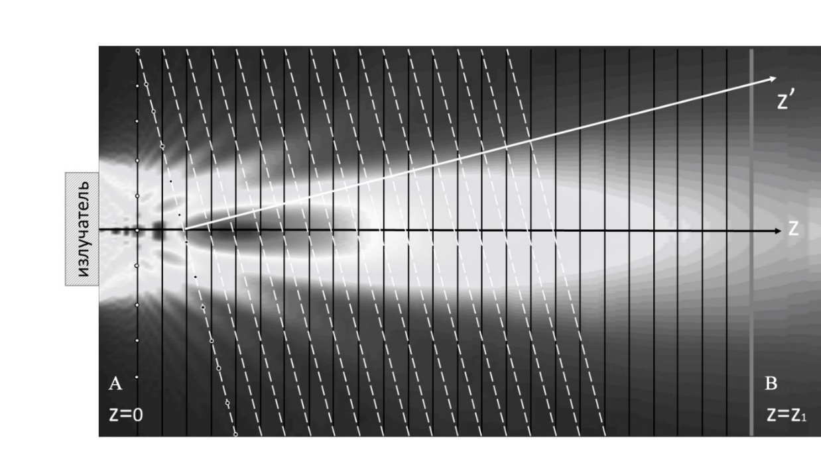
Рис. 1. Схема моделируемой задачи

Работа выполнена при поддержке гранта РФФИ № 11-11-11111.

Литература
- Canney M.S., et al. Acoustic characterization of high intensity focused ultrasound fields: A combined measurement and modeling approach // J. Acoust. Soc. Am. 2008. V. 124 (4). P. 2406–2420.

